Modelica Chemical Library - User’s Guide

Marek Mateják

(first draft)

Abstract

New library for chemical calculations is released. It is equilibrating the electro-chemical potentials of the substances as believed today in modern theory of physical chemistry. The library is very general. The chemical solution has full thermodynamic state with possibility to connect it with thermal, mechanical and electrical package of Modelica Standard Library 3.2.1. This paper show how to implement the lead-acid battery, the hydrogen burning engine and the chloride shift membrane channel in cellular membrane of human red cells. All these examples uses only very small amount of base components such as component for chemical solution, component for chemical substance or component for chemical reaction. Behind these components are only fundamental laws of thermodynamics and physical chemistry. The most of parameters are properties of the chemical substances, so the user does not set the dissociation coefficients of the reactions, because they can be calculated from Gibbs energies of the chemical reaction, which can be expressed from formation Gibbs energies of the substances using Hess’ law.

Introduction

The Chemical library becomes from very successive library for physiological calculations called Physiolibrary. We used this library to implement the biggest model of human physiology of the year 2010 called HumMod. Now we called the model Physiomodel and we crash with this library in extending the more detailed chemical environment of human cells and cellular chemical processes. For example the equilibration of osmolarities on capillary membrane works well, because of small amount of impermeable proteins. However, we found that in cellular membrane these relations was not in good agreement with measured data. These data shows Raftos et al. for human blood red cells, called erythrocytes, where total molarity of plasma is around 289 mmol/L and molarity of intracellular space is 207 mmol/L at osmotic equilibrium. The explanation of these disproportions was hidden in physical chemistry and when we equilibrate the chemical potential of water instead of osmolarity the capillary membrane and also this cellular membrane reach the expected values as measured in experiments. The other problem with old Physiolibrary approach was, that it does not automatically calculate the membrane equilibriums. The very specific blocks for calculating the Donnan’s equilibriums at glomerular membrane was created to reach expected concentrations of electrolytes at semipermeable membrane. However, there was not generated any membrane electric potential, which is the result of this electrolyte’s equilibrium. Even the neural information was spread by simplification describing of amplitudes of frequencies on specific neural drives. Now the new approach can automatically solve the Donnan’s equilibria on semipermeable membrane together with Nernst membrane potential as a simple consequence of the equilibrated electro-chemical potentials of the permeable substances.

We realized during building the new Modelica support of these chemical processes that they are general enough to describe much more than the equilibrium on the erythrocyte cellular membrane. The result is a library, which allows to create any type of chemical reaction in any type of solution at any conditions. We made it in one hand with studding thermodynamics and physical chemistry relations behind. In Modelica it seems really that they can be only rewritten the selected base definitions from these theoretical approach. For example the definition of electro-chemical potential at chemical substance component, the thermodynamic relations at chemical solution component and the simple equilibration of electro-chemical potentials in all components of chemical processes. And all starts to work above our expectations.

Now we define only tree models of substances: ideal gas, incompressible substance and subunit substance. However the user can very easy redefine their own model of substance just by inserting the right expression for pure substance activity coefficient, molar volume, free molar formation entropy and free molar formation enthalpy based on substance data, temperature, pressure, electric potential and ionic strength. As object-oriented design allows also the definition of substance data is the part of the substance model. So the user can design the substance model based on totally different substance data, because this record is used only in the previously mentioned functions of the model, which should be also redefined in new substance model.

In our examples we will work only with ideal gas substances, which will be all gas substances, and with incompressible substances, which will be all liquid or solid substances. The definition data are molar mass of the substance, number of charge of the substance, molar heat capacity of the substance, free formation enthalpy (as known tabulated value for many chemical substances) and free formation Gibbs energy (as tabulated value). And the parameter density only for incompressible substance. So the full definition of ideal gas substance is only to create the record of the five parameters. This way was already defined more than 35 real chemical substances in example package of this chemical library. The usage of these predefined substances data are very simple. It the parameter dialog of the chemical substance can be selected the right record with this data as shown in Figure 1.

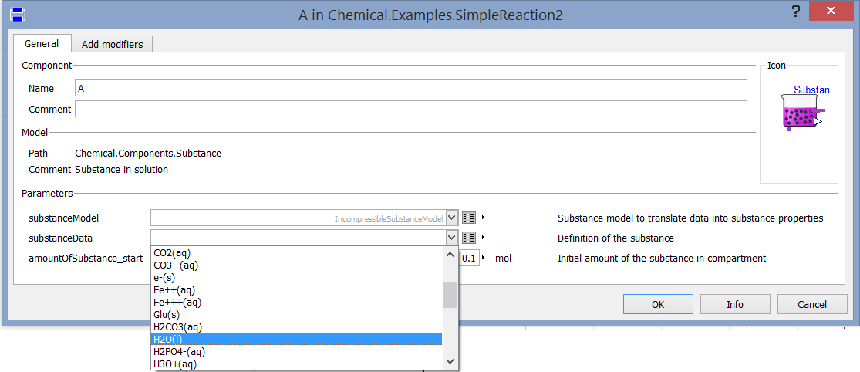

Figure 1, Setting of the predefined chemical substance, where (s) means solid phase, (aq) means dissolved in water, and (g) means gas phase.

This setting is typically the most important setting of each chemical model. All equilibrium coefficients are automatically solved using the selected substance data. As a result for example the chemical reaction component need to define only the stoichiometry coefficient and from the connected substances it reach the equilibrium at the right equilibrium coefficient.

Example of lead-acid battery

The lead-acid electrochemical cells are characterized with two chemical reactions:

PbO2(cathode) + HSO4-(liquid)+ 3 H+(liquid) +2 e-(cathode) <-> PbSO4(cathode) + 2 H2O(liquid)

Pb (anode) + HSO4- (liquid) <-> PbSO4(anode) + H+(liquid) +2 e-(anode)

Building of one cell of lead-acid battery starts with definition of three solutions. Two for electrodes and one for solution. This can be done by drag and drop of Chemical.Components.SimpleSolution class into the diagram. The first we called “cathode” and the second we called “solution” and the last we called “anode”. We set the parameter ElectricalGround to “false” for all of these solutions. Now we can to specify the chemical substances inside the chemical solutions. We drag and drop of Chemical.Components.Substance into the solutions as chemical substances H2O, H+, HSO4- representing the liquid aqueous solution of sulfuric acid, into the cathode PbSO4 and PbO2 representing the charged and discharged state of positive electrode, and into anode the substances Pb and PbSO4 representing the charged and discharged state of negative electrode. As was mentioned for all this substances must be selected appropriate substance data definition, e.g. Chemical.Examples.Substances.Water_liquid, Chemical.Examples.Substances.Lead_solid, .. The last substance very special substance is an electrone. This class is called Chemical.Components.Electrone and it must be added for each electrode. Each of these substances must be connected to the appropriate solution using solution port as expressed in

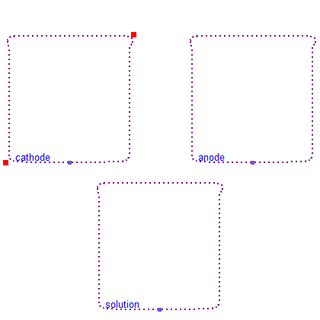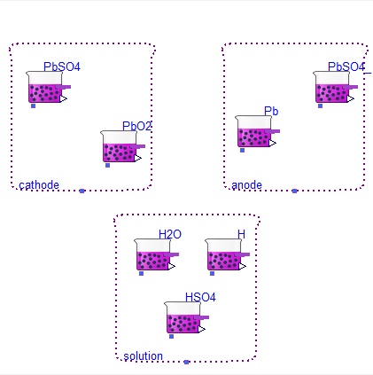

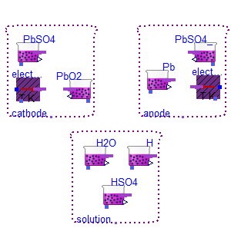

Example of hydrogen burning engine

Example of chloride shift

Results

Discussion